Exercise: Orchestrator Activity

1. Raise Alert:

Custom alerts can be sent to Orchestrator using the [**Raise Alert**](https://activities.uipath.com/docs/raise-alert) activity, which helps you add custom messages in the **Alerts** page

The string added in the activity's **Notification** field is the message which appears in the Orchestrator **Alerts** page. All custom alerts are raised in Orchestrator under the **Process** component.  
Alerts having either **Fatal** or **Error** severity are also included in emails if email [configuration](https://orchestrator.uipath.com/v2018.3/docs/setting-up-email-alerts) is done properly.

Please note that in order to execute this activity in Studio, the **Robot** has to be connected to Orchestrator and the [**Robot** role](https://orchestrator.uipath.com/v2018.3/docs/default-roles#section-the-robot-role) needs to have **View**, **Create**, and **Edit** permissions on Alerts. The activity runs under the Robot which executes it.

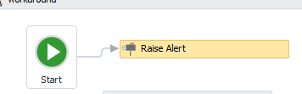 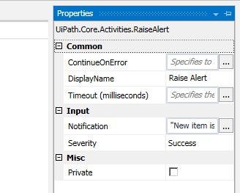

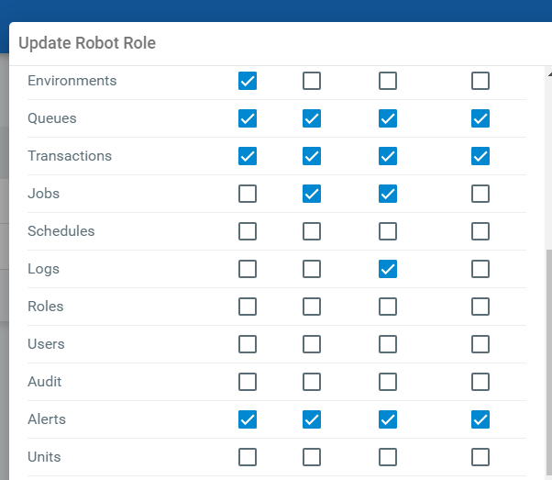

Then on running Studio, Alert is sent to Orchestrator (refer below screen shot)



**UiPath Orchestrator Use Cases**

UiPath’s Orchestrator power comes from its capability of managing your entire Robot fleet. Attended, Unattended or NonProduction, they can all be connected and executed from this centralized point.

* **Attended** - This type of Robot is triggered by user events, and operates alongside a human, on the same workstation. Attended Robots are used with Orchestrator for a centralized process deployment and logging medium.

**suitable for Front office, call center, Help disk etc.… where human intervention is required (agent)**

* **Unattended** - Robots run unattended in virtual environments and can automate any number of processes. On top of the Attended Robot capabilities, the Orchestrator is responsible for remote execution, monitoring, scheduling and providing support for work queues.

**suitable for Back office, example server room, cloud … where human intervention is Not required (human called agent)**

* **Development** - has the features of an Unattended Robot, but it should be used only to connect your Studio to Orchestrator, for development purposes.
* **NonProduction** - similar to Unattended Robots, but they should be used **only** for development and testing purposes.

You are able to run debugging in Studio with all types of Robots.

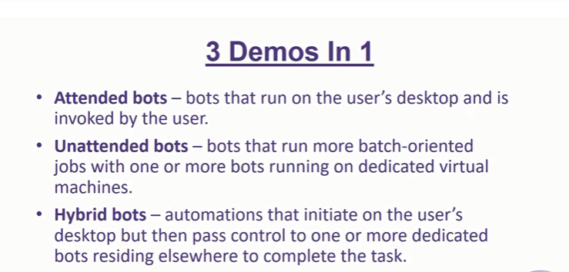

Robotic process automation has risen to prominence in recent years thanks to its ability to perform repetitive tasks quickly and efficiently. Software bots function over existing IT infrastructure, which means they can also move fluidly between different programs as a human user would.

While a number of RPA software platforms can be used to design and deploy software robots (Blue Prism, UiPath, Automation Anywhere and others), there are only two high-level breeds of RPA:

1. **Attended RPA:** Bots respond to employee-triggered actions by automatically completing certain tasks to simplify a workflow.
2. **Unattended RPA:** Bots automatically complete back-office functions at scale with minimal employee intervention.

Enterprises that hope to maximize RPA’s effectiveness within workflows first need to understand attended vs unattended RPA at a deeper level. Knowing the relationship between the two will help IT and business decision-makers use automation to create well-oiled workflows.

## Attended RPA: Cooperative bots

Attended software bots typically run on local workstations, meaning they manipulate the same front-office programs as your human employees. This is sometimes referred to as desktop automation because software bots take actions on the local machine. Since attended RPA bots respond exclusively to user prompts or to human-triggered events, you might also recognize them by a different name: personal assistant bots or software assistants.

The key benefit of attended RPA is that it lets users quickly coordinate simple but tedious tasks like searching for and retrieving a specific customer’s data. For example, attended bots might retrieve data from one application and bring it into a different application so a call-center agent won’t have to toggle between them. Actions such as this allow humans – contact center workers in this case – to focus on value-based tasks such as finding creative solutions to a customer’s problem.

Users can tell bots to take actions through explicit command buttons on an RPA solution’s client tool or through an embedded, on-screen button within an existing user interface. Alternatively, a specific bot can be implicitly attached to a specific activity without having any visible influence on UI.

In practice, attended RPA lets human employees act as coordinators of their own workflows. Time-consuming administrative functions that might require sorting through spreadsheets or copying and pasting data from one field into another can be executed on-command or directly in response to a human-generated event.

Consequently, attended RPA streamlines otherwise clunky workflows for business users. These employees are thereby liberated to focus on judgement-based functions rather than waste time on tasks that RPA bots can perform faster and with fewer errors.

## Advantages of attended RPA

Attended RPA clearly acts as an empowering agent for workers by liberating them to focus on processes at a higher level and from a more qualitative lens. But it also has several unique business advantages over unattended RPA. These include:

1. **Swift implementation:**Robotic process automation has [four primary stages](https://www.arrowdigital.com/insights/2017/11/introducing-the-rpa-maturity-curve)of maturity: personal assistant bots, personal multiplication bots, organization scaling and innovational enablement. Attended RPA represents stages one and two. Business users work with IT staff in these stages to choose a leading RPA tool set – namely UiPath, Automation Anywhere or Blue Prism – and to create straightforward automation instances with immediate time-saving benefits.
2. **Expeditious return on investment:**Time saved equates to money saved. Both facilitate new opportunities to introduce value-add processes to leaner workflows. In this sense, attended RPA typically generates more immediate ROI.
3. **Less disruptive to existing workflow:**Attended RPA usually fixes specific problems encountered by employees. It does not replace or completely overhaul workflows with advanced automation; rather, it enhances them with task-specific deployments of software robots. Accordingly, attended RPA is a very non-disruptive enhancement to existing processes.

As we’ll discuss later in this post, these advantages don’t necessarily make attended RPA better than unattended RPA in every instance. Nevertheless, attended RPA is the next logical step for organizations that are still standing on the shore of automation but are ready to get their feet wet.

## Unattended RPA: Back-office automation

Unattended RPA is primarily used for back-office functions that have a more enterprise-wide impact on workflows. Unlike attended bots which run on individual user workstations, unattended bots usually run on an organization’s servers with little to no human intervention – but they’re not to be confused with artificial intelligence (AI) in that they’re not “self-learning.”

Once deployed, unattended bots will run on predetermined schedules or in real time, 24/7/365. They automatically handle the aggregation, sorting, mapping, analysis and distribution of large quantities of organizational data. These higher-level data streams and processes ultimately improve the workflows of individual departments, and at an even more granular level, the workflows of individual people within them.

Some examples of the types of processes unattended RPA bots will automate include:

* Claims processing [at an insurance company.](https://www.arrowdigital.com/insights/2018/04/rpa-can-usher-in-a-new-age-for-the-insurance-industry)
* Application processing for customers opening accounts [at a bank.](https://www.arrowdigital.com/insights/2018/04/how-the-banking-industry-should-leverage-rpa-solutions)
* Generation and distribution of invoices at a wholesale supplier.
* Responses to interactive voice response (IVR) queries.

Large-scale clerical functions such as these happen faster and more accurately when executed by unattended RPA bots.

Unlike attended RPA bots, which can only be controlled by the local user admin, unattended RPA bots can be controlled and scheduled remotely since they usually operate on virtual machines. Granted, more IT involvement may be necessary for the configuration of unattended bots. Nevertheless, unattended RPA has greater collaborative potential than attended RPA by nature of its scale.

## Advantages of unattended RPA

Once set in motion, unattended software robots continue to function with minimal human intervention. By comparison, attended bots rely on human users to launch a task and move the process forward.

Exceptions will occasionally occur in unattended RPA that demand the attention of department managers and possibly IT support. But generally speaking, unattended bots continuously execute a process and interact with applications independent of human involvement. This yields several key advantages, including the following:

* **Enables innovation:**Digital transformation is the primary advantage of unattended RPA. Unattended bots can act as integrators that push and pull data between legacy systems and new applications. They can also streamline integrations between internal systems and third-party solutions. As a result, organizations can evolve their processes and introduce new technologies that would otherwise be far too costly, complex and disruptive to implement.
* **Optimizes enterprise-wide processes:**Higher-level processes that influence the more granular aspects of workflows are automated with unattended RPA. This creates opportunities to automatically set tasks in motion at any time, day or night. Accordingly, customer requests can be processed faster and more efficiently.
* **Possesses greater ROI potential:**For all of the reasons mentioned above, unattended RPA has further-reaching ROI potential, presuming it’s implemented strategically. Organizations that leverage RPA may see anywhere [between 20 percent and 200 percent](https://www.mckinsey.com/business-functions/digital-mckinsey/our-insights/the-next-acronym-you-need-to-know-about-rpa)ROI, according to McKinsey & Company. Enterprises that evolve into the latter stages of RPA maturity (organizational scaling and innovation enablement) will almost invariably make use of unattended bots to enable frictionless digital transformation. This will push them nearer to the 200 percent end of the ROI spectrum.

Organizations that are prepared to use RPA to enable innovation and transform their workflows have the most to gain from unattended software robots.

While the ROI potential is phenomenal, unattended RPA tends to be a larger, more strategic investment when compared to attended RPA, which is leaner and more tactical. Therefore, any implementation involving unattended RPA should be highly premeditated and thoughtfully mapped to a long-term business outcome.

## Better together: Attended ~~vs~~ and unattended RPA

The either/or mentality hardly applies to the question of attended vs. unattended RPA. They are not mutually exclusive.

If you think of an enterprise workflow like a tree, unattended RPA handles the bigger-picture administrative processes that would take place within the trunk. These high-level, back-office functions help streamline internal organization workflows. This ultimately enables more organized processes on the frontend of those workflows, such as customer-facing interactions.

Employees can then further optimize front-end processes by using attended RPA to more quickly invoke specific information that exists in multiple databases. This type of desktop automation is invaluable since it helps human workers handle ad-hoc administrative processes more efficiently.

The combination of attended and unattended RPA, then, is workflow optimization at its finest.

## Preparing for the future of RPA

In the coming years, [organizations will use a combination](https://www.mckinsey.com/business-functions/digital-mckinsey/our-insights/intelligent-process-automation-the-engine-at-the-core-of-the-next-generation-operating-model) of unattended and attended RPA, machine learning and cognitive agents to facilitate what McKinsey & Company calls “intelligent process automation” or IPA. The goal of IPA is more or less the same as RPA’s current goal: to automate “busy work,” create smarter digital workflows and give human workers the freedom to assert their true value in the workplace.

As the most mature foundational component of IPA, RPA must be priority No. 1 among organizations targeting workflow optimization and digital transformation. For companies that are just getting their feet wet, we recommend downloading [our RPA buying guide](https://www.arrowdigital.com/insights/rpa-vendor-comparison). There’s no better way to begin exploring RPA than by understanding the potential of the tools that make it possible.

Attended and unattended :

<https://www.youtube.com/watch?v=SkE9Ptq7YEE>

<https://www.youtube.com/watch?v=umgEyj9aU1A>

1. Orchestrator HTTP Request

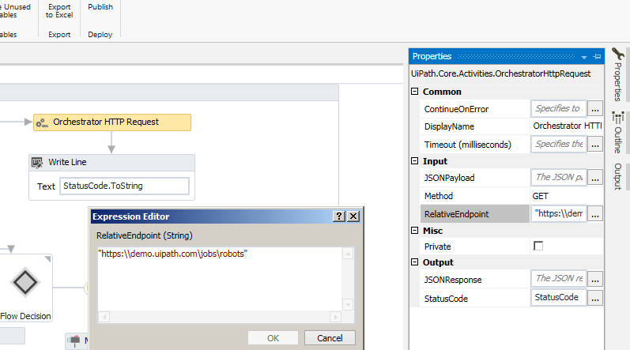

Displays the status code ‘200’ on the request endpoint

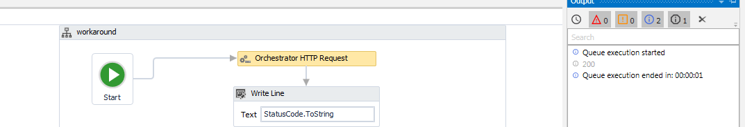

Get Jobs

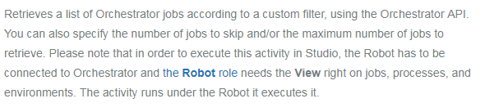



Start Job using UI Studio

Enables you to start a job on Orchestrator on a specified number of Robots. Please note that in order to execute this activity in Studio, the Robot has to be connected to Orchestrator and [the **Robot** role](https://orchestrator.uipath.com/v2018.1/docs/default-roles#section-the-robot-role) needs to also have the create and edit rights on jobs, as well view on processes and environments. The activity runs under the Robot it executes it.

* **ProcessName** - The name of the process you want to execute, in the packageName_environment format.

